Tip 1: Avoid Soap.
Soap was first invented more than 2000 years ago. Soap makes us clean by removing the oils we produce to lubricate the skin from our bodies, as well as the skin bacteria that is contained in the oils.
Soap is no longer the best option to clean with. Soap can cause the skin to dry out too much resulting in cracking of the top layers of your skin, called superficial layers.
Micro-organisms that live on the skin can get into these cracks and this can result in itching and soreness. This particularly affects the genital skin.
Using any soap product above the waist can mean that the product will wash onto the genital skin when you rinse in the bath or shower.
Washing with just water can also dry out the genital skin. It would be best to use a soap substitute over the entire body instead.

Need More Information?

If you need to contact the Chalmers Centre, our details are:

Chalmers Centre for Sexual Health
2a Chalmers Street
Edinburgh
EH39ES

Tel: 01315361070

Layout & Readability reviewed by NHSL Patient & Carer Information Team v2.0 Nov2019, For Review: Nov2021


Female Genital Washing Advice
Information for you

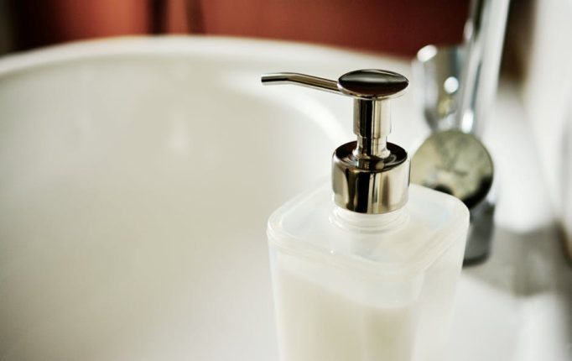

Tip 2: Use a Soap Substitute
A more modern way to wash is to use a soap substitute. Soap substitutes remove the bacteria that make us smell but add moisture to the skin, instead of taking it away. If your skin is well moisturised, this will help to stop it from getting itchy and sore.
Soap substitutes are widely available in all pharmacies. Depending on the brand required you can get them off the shelf or from the pharmacy team without a prescription. Ask the pharmacy for advice if you are not sure. Some brands to consider:
Aqueous Cream
Cetraben
Cetaphil
Dermol 500
Diprobase
Epaderm
Hydromol Ointment
Oilatum
ZeroAQS
Tip 3: When washing hair
It is important not to let shampoo or conditioner run onto the genital skin.
This means you should not wash your hair in the bath and when in the shower keep your head forward when rinsing products from your scalp.
Tip 4: Avoid bubble baths, essential oils or soap/shower gels in the bath
They will get onto the genital skin and may cause irritation. You can buy non-soap bath additives such as Aveeno Bath oil instead.
Tip 5: Avoid wet wipes
Do not use wet wipes on the genital skin-they are designed for babies who have much ‘tougher’ genital skin than adults.

Tip 6: Avoid feminine hygiene products
Do not use feminine washing products – even if they say they are pH balanced. They are highly disruptive to healthy bacteria in the vagina.
Tip 7: Avoid Douching
Do not ‘douche’- this means washing out the vagina with water or other products. This damages the healthy vaginal organisms and alters their natural balance in the vagina.
Tip 8: Avoid Fabric Softeners
Do not use a fabric softener or a 2 in 1 washing product when washing your clothes.
The perfume in these products gets onto the genital skin and causes drying and damage to the skin.

